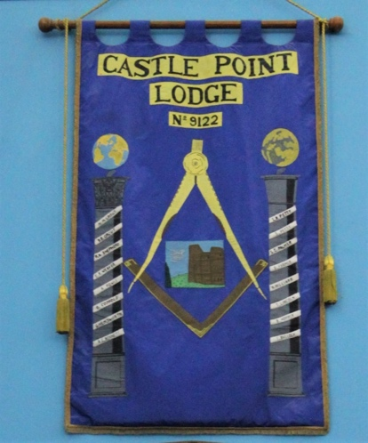

Castle Point Lodge No. 9122 was consecrated on the 22nd June 1984.

Lodge History

The dream of a new Lodge on Canvey Island was that of our Worshipful Brother Leslie Robert (Les) Petty and was to be called Castle Point Lodge, after the newly formed local district council, which incorporated the Parishes of Canvey Island, Benfleet, Thundersley and Hadleigh. The two prominent local features, Hadleigh Castle dating back to around 1231 A.D. and Canvey Point dating back to Pre-Roman history coming together to form the name, therefore an image of the castle ideally positioned in our Lodge Banner within the points of the compasses.

The Lodge meets five times per year at the Rochford Masonic Centre, South Street, Rochford, on the first Tuesday in February, second Tuesday in March, May and October, and the fourth Tuesday in November, typically with a 4pm start, with dinner to follow around 7.30pm.

The Lodge continues to thrive with over 50 members with a diverse range of ages and occupations, from various building trades, consultants, I.T., teachers, insurance brokers, white collar, to car salesman and car repair to name but a few, with new members continuing to grow year on year,

We have an active social calendar outside of our normal meetings, which is linked with our Lodge of Instruction, which includes Christmas supper, Summer recess drinks and end of Summer break BBQ, held at local venues for easy access for all, along with our annual Ladies Night Festival.

With regards to our Lodge workings, we practice Emulation Ritual to a high standard, evolving with the changing times, embracing any new ideas particularly from our younger Brethren, but at the same time maintaining the old traditions that will always remain.

